THINBACKUP In Jenkins  
  
**step1**: goto manage jenkins and thenafter click managepulgins install pulgin as thinbackup .  
  
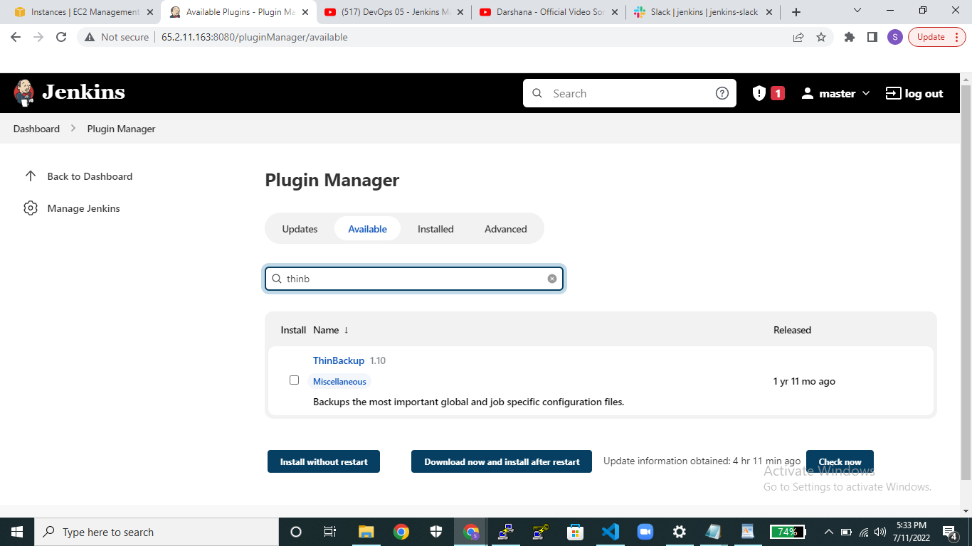  
  
**Step2**:after downloading the plugin click on thinbackup portal.  
  
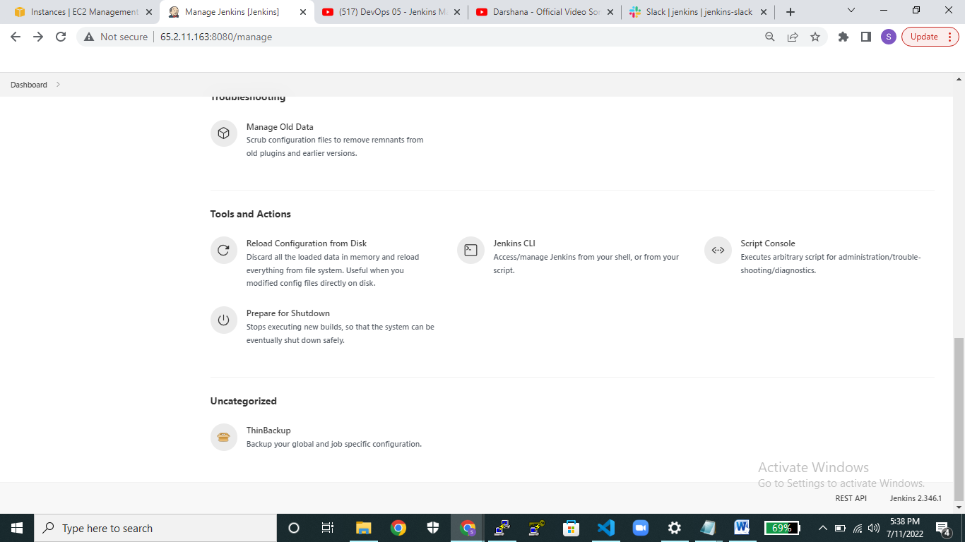

**step3**: click on settings   
  
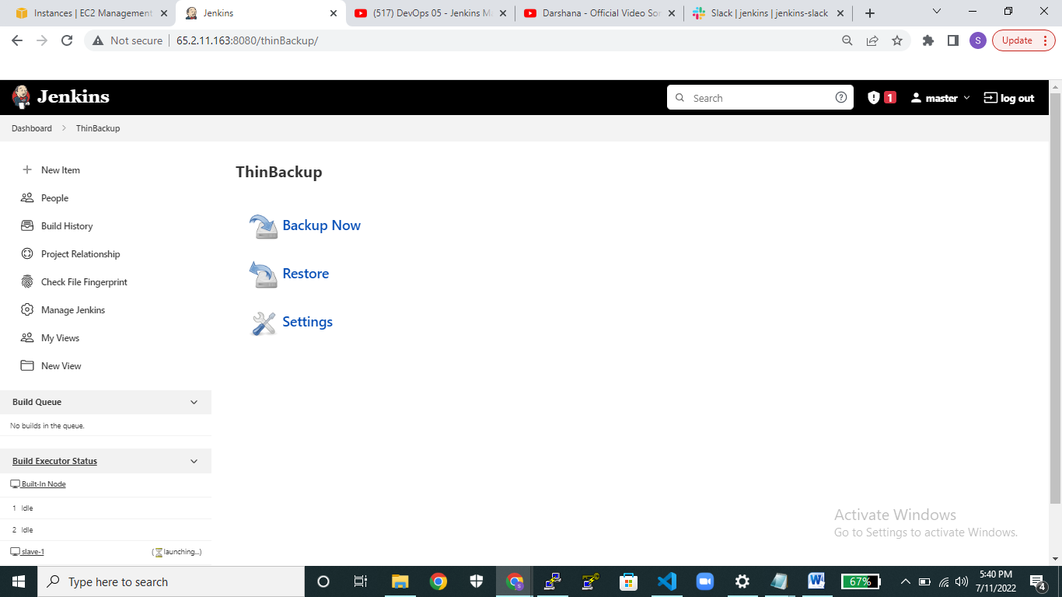  
  
**Step4:** clickon settingspage and in backup directory give any folder name path in that field .   
and also backup schedule those all other options available if you want provide those things you can use it as per requirements.  
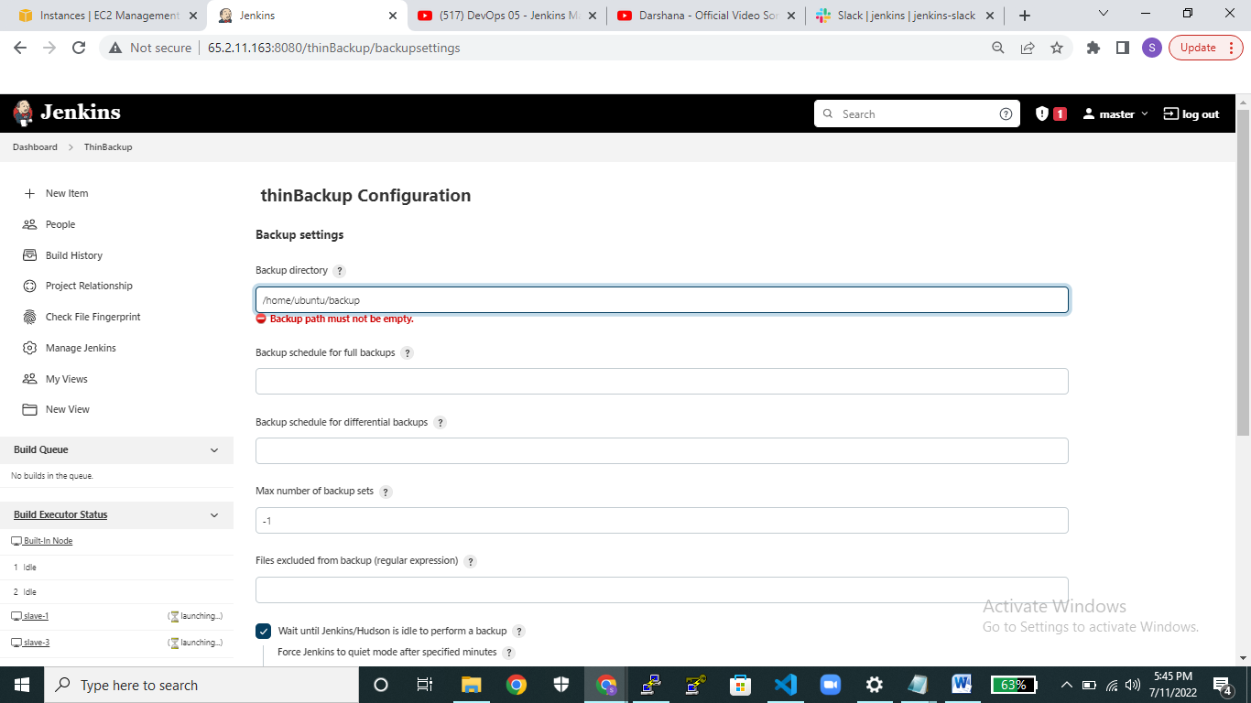  
  
  
  
  
  
  
  
  
  
  
  
And in that setting portal page only select backup build results over there number of options available . select backup plugins archives and save it.  
  
 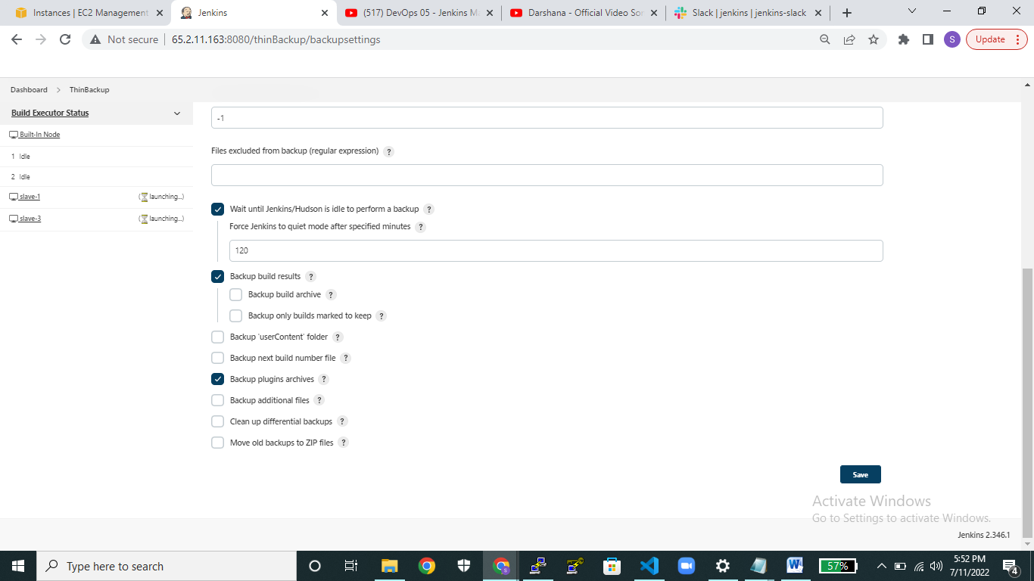 **step5:** then click on backup to take backup data or if want to restore the data you can click it on restore .  
  
